Call Center Implementation Guide

1.0 Introduction

The Purpose of the Call Center application is to allow customer service agents to assist customer queries about their online store orders. The application is available for all retailers and built to adapt to the custom storefront applications.

2.0 Functional Specification

The Call Center application is a self-contained entity that customer service agents can use to search and find information about customers and orders from the Demandware store. Below are screen shots and details for each of the Call Center application screens.

2.1 Agent Login Screen

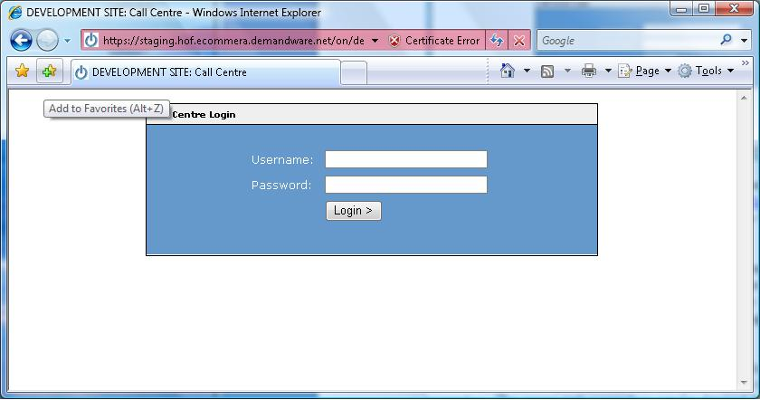

URL : The Call Center login screen can be found in a browser by entering the stores domain followed by the keyword callcenter. (Ex. http://domain.com/callcenter)
This is a custom URL mapping that is setup in the Business Manager for the site.

Agent Account: Each agent is set up with a Call Center account. This account is an actual Demandware Business Manager account with the user rights “Agent User” granted. The customer service agent can also log into the Business Manager to and change their account details. Any addition Business Manager privileges can also be assigned to this account.

Login Criteria: A customer service agent must have a valid, enabled account, username and password as well as a secure web SSL connection in order to log into the Call Center application. The secure web connection can be obtained by using the https protocol in the URL. The “callcenter” URL mapping automatically directs the browser to an https URL.
NOTE: The username and password fields for the login screen are case sensitive.

2.2 Customer Search Screen

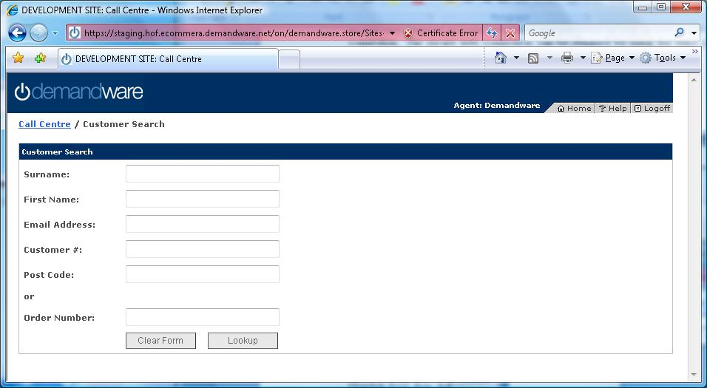

The customer search screen allows an agent to search for an existing customer within the Demandware store based on information stored in the customer’s profile.

Search Fields: The search fields are broken up into two parts, a search by customer profile search and a search by customer order number search. The two search fields operate independently of each other.

If an order number is entered into the Order Number field, the customer profile fields are ignored. The application searches for customers that have placed an order with the entered order number only

Mandatory Fields: The agent must enter a value for the customer’s surname, email address or order number to perform a search. A search that does not specify at least one of these values results in a form validation error message. All other fields, (first name, customer number and post code) are optional.

Search Syntax: All profile search fields are based on a “like” search, which allows the agent to enter the first few letters of the search criteria. For example, when searching for a customer by email address test@store.com, the agent can just enter tes in the email address field. The order number field does not support the like search, it requires the entire order number to be entered.

Wildcard searches can also be performed within the search criteria for a field using the * character. The * takes the place of any other character within the text.
For example entering Te*t in the surname field returns any users that have a surname starting with Test or Tent or Terant.

In order to search for all customers within the Call Center, the agent can enter just an asterisk in any required field.

Agent Login Tracking: When an agent logs into the Call Center application, the application records the agent name, domain and login date/time in a .csv file on the server.

2.3 Customer Search Results Screen

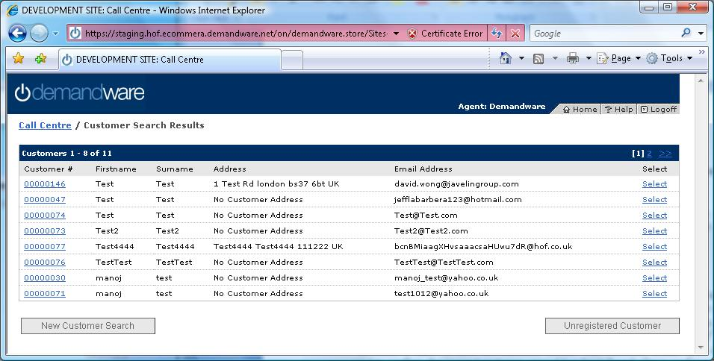

The customer search results screen displays a summary of customer records that match the specified search criteria. The agent can click on the “select” or “customer #” links to view the details of any customer record to view the full customer record, to confirm it is the correct customer. Once confirmed, the agent can click the “Confirm / Log in as Customer” button to log in as the customer. The agent can then access the storefront as the customer, for example to place orders on behalf of the customer with promotions available to that customer, edit the customer’s profile information, and so on.

If the customer is not found in the search results, the agent has the option to click the “Unregistered Customer” button to visit the storefront to setup a new customer account and/or place an order for the customer.

Pageable Results: The results display the total number of users that match the specified search criteria, as well as the number of users displayed on the current page. The number of customers to show on each page is defined in a custom preference. If there are more results than the preferred page size, the agent can scroll back and forth through the result pages or jump to the end or beginning of the total results.

Security Question: The security question box enables the agent to view the security question and answer that the customer has entered during the account setup on the online store. This box can be enabled or disabled based on a custom preference. The customer question is not enabled by default.

2.4 Customer Details Screen

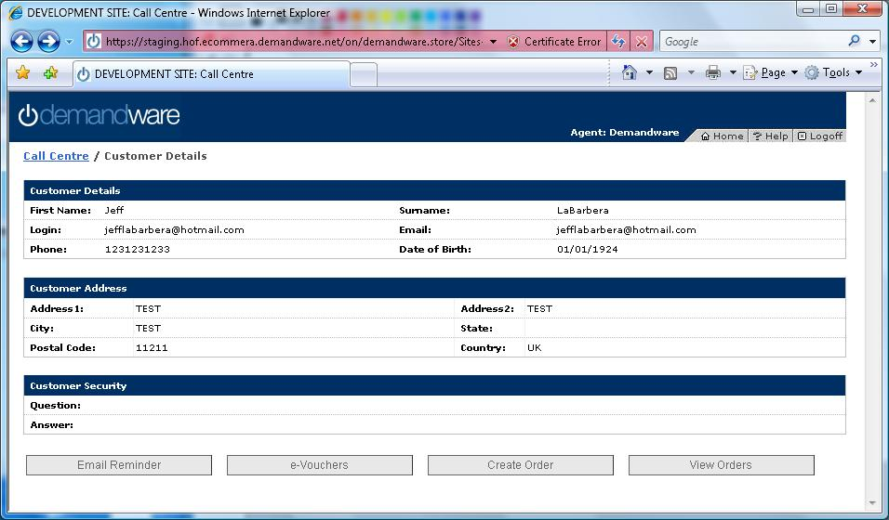

The customer details screen shows the customer’s profile details as well as the customer’s address. At this stage the agent is logged in as the customer and can perform tasks on “Behalf” of the customer. The agent has the following options:

- Email reminder: Generate and Send a new password to the customer
- eVouchers: Create and send an e-Voucher to the customer
- Create Order: Jump to the storefront to place an order “as” the customer or manage the customer’s profile
- View Orders: View the customer’s orders.

2.5 Email Reminder Screen

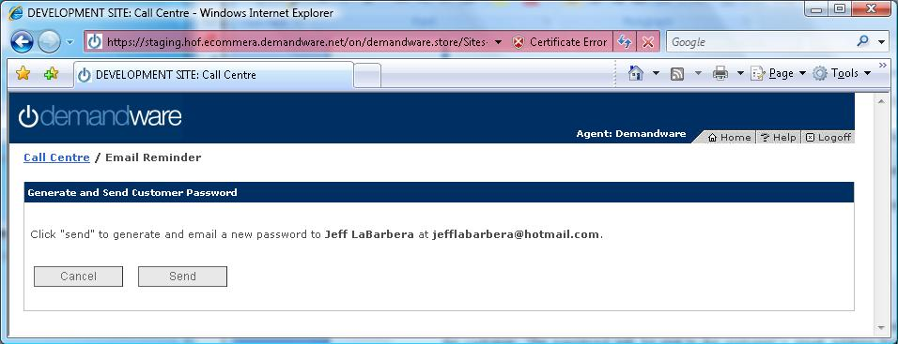

The Email Reminder screen gives the agent the ability to generate a new password for the customer. The password is sent to the customer’s email address found in the customer’s profile. Once the password is generated and sent, the screen displays a confirmation and the new generated password for the customer.
2.6 eVouchers Screen

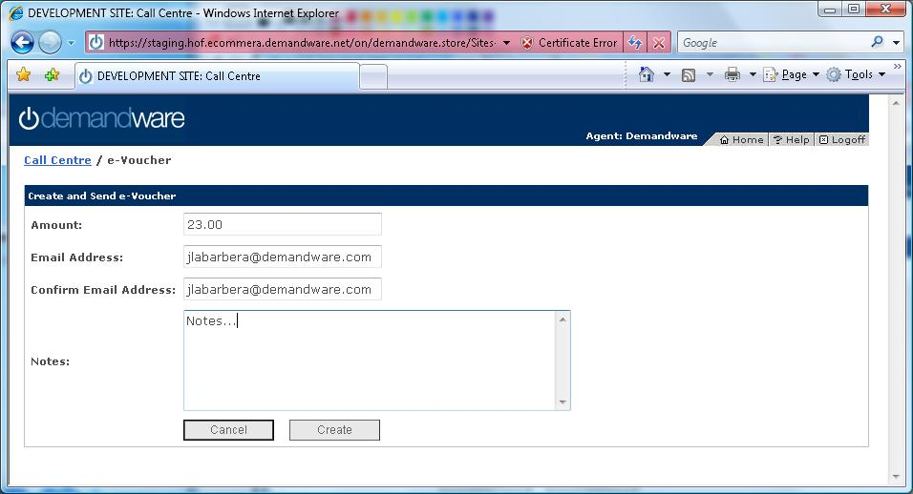

The eVoucehers screen gives the agent an option to create and send a Demandware electronic gift certificate code to a customer. When the agent completes the form and clicks “Create,” this creates a Demandware gift certificate for the storefront, and sends an email to the customer with a voucher code to enter as a form of payment into the storefront during checkout.

eVoucher Form: The amount field specifies the eVoucher amount based on the current currency of the storefront. This field is validated to contain only numbers in a decimal format. The maximum eVoucher amount is specified in a custom preference. The email address fields are pre-populated with the currently logged-in customer’s email address, although this can be changed by the agent.

After the eVoucher has been created the screen displays a confirmation as well as the eVoucher number of the generated gift certificate.

2.7 View Orders Screen

The view orders screen allows the agent to browse and display the orders placed by the customer.

Order List: The list of orders is pageable if the total number of orders is greater than the order page size. The page size for the orders is specified in a custom preference. Selecting and order number displays the details for the order.

Order Details: The order details screen displays the details of the selected order. It contains all the product line items from the order, any discount or promotions for each line item, order total, and gift certificates applied to the order.

Addresses / Payment Information: The order detail screen displays the addresses that have been entered for the order. The billing address and payment information are always displayed on the right hand side of the order. A custom preference can be set to display a single shipping address along with the billing address. If the storefront handles splitting shipments of orders, then the customer preference can be set to display the shipping address and shipping method per product line item in the order details.

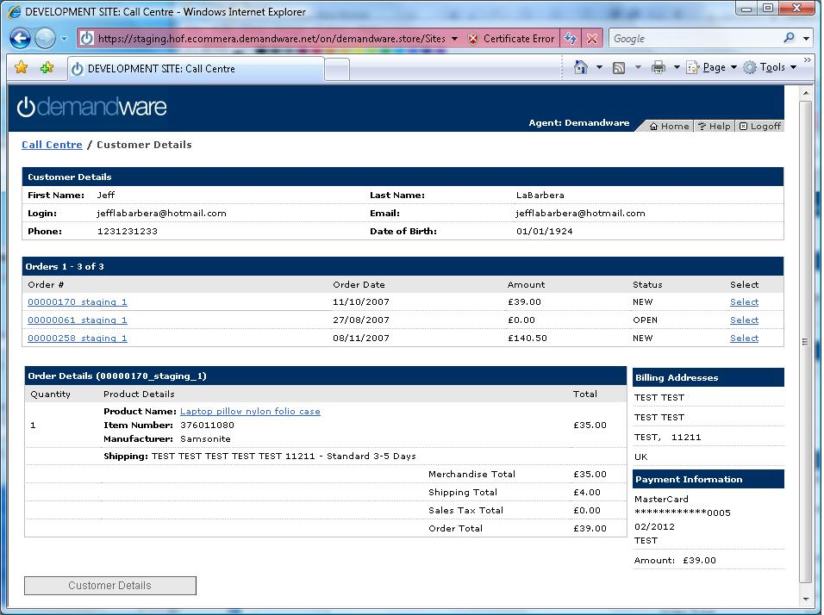

2.8 Create Order

On the customer details screen the agent has the option to click “Place Order”. This button brings the agent to the storefront, logged in as the customer. The agent can then create an order or manage the profile of the customer.

2.9 Call Center Header - Storefront

When an agent navigates to the storefront as a customer by clicking “Place Order” or “Un-registered Customer”, a banner is displayed on the top of the storefront pages. This banner is used to notify the agent that they are logged in as a customer, displaying the customer’s name.

2.10 Call Center Customer Account Screen - Storefront

When an agent is logged into the storefront as a user, they have the ability to create an account for an unregistered customer. If the customer does not have an email address, the agent can click the “Generate Login Information” button. This pre-populates the email address and password fields with generated values.

The domain of the generated email address as well as the default password is set in a custom preference.

2.11 Bypass payment for Free of Charge Orders – Storefront

Some retailers set up a promotion that allows agents to place an order for zero cost for the products and shipping. This is called a “Free of Charge Order”. When a customer service agent is placing an order for a custom that is free of charge, they cannot enter in the credit card information for the default checkout processes. In this case a link has been added below the checkout payment form that displays only for currently logged-in agents that allows the agent to bypass the payment information form.

3.0 Implementation

3.1 Call Center Cartridge

Within the Call Center project, the app_cc cartridge contains the majority of the files used for implementation. There are a few storefront specific files that can be integrated into the core storefront application as described below.

3.2 Call Center ISML Templates

All the templates for the Call Center application are store within the templates\default\callcenter directory. The templates are placed in this directory in order to not conflict with any other of the storefront cartridge templates.A list of templates and brief descriptions are below.

- cc_footer.isml : Contains the footer html and text for all Call Center pages
- cc_header.isml: Contains the header html and text for all Call Center pages including the Demandware logo and top navigation links. This template also includes the ajax javascript to keep the session alive.
- cc_storefront_header.isml : Used for the header on the storefront pages to display the agent name and currently logged-in customer. This template can be copied to the storefront application as templates/default/callcenter/cc_storefront_header.isml to customize it on a per-storefront basis.
- customer_details.isml: Used to display the customer details for the Call Center
- customer_orderdetails.isml: Used to as the base page for order display.
- customer_orderdetails_lineitems.isml: Displays the details all a selected order
- customer_orders.isml: Displays the list of customer’s orders
- default.css: Contains all the style sheets for the Call Center application
- help.isml: This templates reads the help text from a custom preference
- keep_session_alive.isml: This is a blank template that is called by an ajax call in the header to keep the session alive
- login_form.isml: Contains the login form for the Call Center
- miniaddress_bill.isml: Included on the order screen to display the billing address for the order
- miniaddress_ship.isml: Included on the order screen to display the shipping addresses for the order
- minicreditcard.isml: Included on the order screen to display the payment information for the order
- modules.isml: This template contains all the modules/custom tags for the Call Center application.The tags included are for calling the paging and mini address / credit card templates.
- paging_bar.isml: This template is included to display and handle paging of lists for the customer search results and order lists
- passreminder_form.isml: Contains the form for the password reminder page
- passreminder_conf.isml: Displays the confirmation and generated password after a password reminder is sent.
- passwordemail.isml: This template contains the format of the email that is sent to a user for the password reminder section.
- search_form.isml: Displays the search fields for the customer search page.
- search_resutls.isml: Displays the list of customers from the customer search form.
- voucher_form.isml: Displays the text fields for the eVoucher creation form
- voucher_conf.isml: Displays a confirmation and the generated gift certificate number after a eVoucher is created.
- voucher_email.isml: This template contains the format of the email that is sent to a user when an eVoucher is created and sent..

3.3 Call Center Pipelines

- CC-Authentication: This pipeline is called internally by the other pipelines within the Call Center application. It is called for every request to check if an agent is logged into the Call Center. If an agent is not found in the session, the user is redirected to the login screen. This automates a logout when the session expires, prevents an un authorized user form entering the Call Center as well as preventing bookmarks of the Call Center pages.
- CC_Customer: This pipeline handles the display for the customer details pages.
- CC_Login: Used to display and handle the login of agents.
- CC_PasswordReminder: Used to handle the password reminder section
- CC_PlaceOrder: This pipeline is called when the user jumps to the storefront pages. It is used to authorize the agent user before entering the storefront from the Call Center.
- CC_Search: Used to handle the searching of customers
- CC_Voucher: Used to handle and display the eVoucher section
- CCStorefrontHeader: Used to render the header on the storefront pages, to display the agent name and currently logged-in customer.

3.4 Call Center Scripts

All the Demandware scripts are located in the scripts/callcenter directory of the app_cc cartridge

- AddStatusToDictionary: This script is used to add a DW Status object to the dictionary with a static message. The Message can be hardcoded into the pipelet configuration or passed into the pipelet
- ConvertOrdersToCustomers: This script takes the order results from the SearchSystemObject pipelet and creates a new Iterator of the corresponding customers.
- libDateParser: This is a helper script with functions used to format date objects
- PostCodeFilter: This script filters out the customers that do not have the passed Postcode entered in the customer search.
- SearchPrepare: This script prepares the search criteria from the Call Center to allow wildcards. This script also validates that one field was entered in the search criteria. If at least 1 field has not be populated, the script returns with ERROR_Search which contains the a string with the associated error message.
- TrackagentLogin: This script is used to write a record to a text file on the server for each successful agent login. The date and time of login, domain name and agent user name are written to the file.
- VouceherValidate: This script validates the input fields on the eVoucher creation form
- generate_login_by_agent.isml: This template has been moved to ecommera core cartridge. It is used to display and handle the automatic generation of customer email address and passwords by the agent on the storefront registration page.

3.5 Integrating the Agent Storefront Header

To integrate the agent banner into your storefront’s header:

- Add the following to the top of the global header ISML template (in SiteGenesis, this is components/header/header.isml):

<iscomment>Show customer agent banner if logged in on behalf of a customer using call center application</iscomment>
<iscomponent pipeline="CCStorefrontHeader-Start" />

- Add the following to the global HTML head template (in SiteGenesis this is components/head/htmlhead):
<iscomment>Styling for Call Center agent banner when logged in on behalf of a customer</iscomment>
<isif condition="${pdict.CurrentSession.userAuthenticated}">
<link href="${URLUtils.absStatic('/callcenter/css/storefront_header.css')}" type="text/css" rel="stylesheet" />
</isif>

4.0 Site Preferences

Call Center preferences for each retailer are available that appear in the site preferences area of the Demandware Business Manager. To create these preferences in Business Manager, go to Administration > Site Development > Import & Export to upload and import the file callcenter_sitepreferences.xml, included with the CallCenter project files.

After importing this file to define the site preferences, the following preferences are available for each site under Site > Preferences > Custom Preferences > CallCenter.

eVouchers Enabled

This is a Boolean flag that enables the retailer to turn eVoucher (Demandware electronic gift certificate) creation on or off removing the eVoucher button from the customer detail screen. It is disabled by default.

eVoucher Amount Limit

This parameter defines the maximum amount that an eVoucher can be created for. The default is 0, which is no limit.

Customer Search Page Size

This parameter specifies the number of customers to display per page on the customer search result screen. Default Integer value is 8.

Customer Order Page Size

This parameter specifies the number of orders to display per page on the customer order list screen. Default Integer value is 8

Help Screen HTML

This Site Preference displays the HTML/Text for the Call Center help screen.

Multiple Shipping Addresses Enabled

This parameter specifies if the order detail screen should display a single Shipping Address in a block format or Multiple Shipping Addresses per product line item.

True : Displays a Shipping Address per line item
False : Displays one Shipping Address

Security Question Enabled

This parameter specifies is the customer details screen should display the customer’s security question and answer

True : The customer’s security question and answer is displayed
False : The customer’s security question and answer is hidden

5.0 URL Mappings

In order to have a shortcut to the Call Center a static mapping needs to be created in the Static Mappings section of the Business Manager.

/callcenter p,https,,CC_Login-Form

